EPH-International Journal of Applied Science

Volume - XX, Issue - XX
Month – Year
DOI-https://doi.org/ XXXX

Article Title (14pt Bold)

Author Name¹
^{1*}Author Affiliations (10pt)
*Corresponding Author: XYZ (10pt Bold)

Received:- dd-mm-yyyy, Revised:- dd-mm-yyyy, Accepted:- dd-mm-yyyy, Published:- dd-mm-yyyy

ABSTRACT (11 pt, Bold)

Write your abstract here (150–250 words). The abstract should briefly describe the objective, methodology, key results, and conclusion of the study. Avoid citations.

--------------------------------------------------

KEYWORDS (11 pt Bold)
Keyword1, Keyword2, Keyword3, Keyword4, Keyword5

1. INTRODUCTION (12pt Bold)
Write the background of your study. Explain the importance of the topic, previous research, and the gap your study addresses. End with the objective of your research. (12pt)

2. Materials and Methods (12pt Bold)
Write your content (12pt)

2.1 Sub Heading (12pt Bold)
Describe the system or study area.

2.2.1 Sub-SubHeading (12pt bold)
Explain your research method (e.g., Life Cycle Assessment).

3. RESULTS (12pt Bold)
3.1 Sub heading
Write your content

Table 1: Physical Appearance Tablets of Different Brands
Brand | Colour | Shape and Others
Content 1 | Color 1 | Shape 1
Content 2 | Color 2 | Shape 2
Content 3 | Color 3 | Shape 3
Content 4 | Color 4 | Shape 4
Content 5 | Color 5 | Shape 5

“Formatting for image”

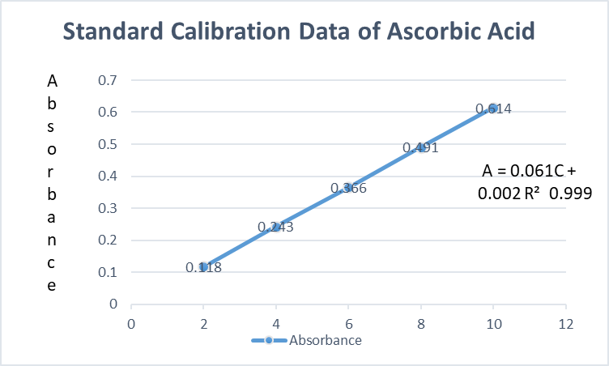
Figure 1: UV Standard Calibration Curve of Ascorbic Acid at 295.4

5. DISCUSSION (12pt Bold)
Write your content (12pt)

6. CONCLUSION (12pt Bold)
Write Your content

REFERENCES (12pt Bold)
All references must be written in Times New Roman font with a font size of 11 pt and should follow APA 7th edition formatting consistently throughout the reference list.

In-text Citations:
Citations should include the author's surname and year of publication.
Examples: (Sharma, 2022), Sharma (2022).
For two authors: (Sharma & Kumar, 2021).
For three or more authors: (Sharma et al., 2020).

Journal Article Format:
Author, A. A., Author, B. B., & Author, C. C. (Year). Title of the article. Journal Name, Volume(Issue), Page range.

Formatting Rules:
- Only journal articles should be included in the reference list.
- Journal names must be written in full and italicized.
- Article titles should be in sentence case.
- Ensure all in-text citations are listed in the reference section.
- All reference must be in 11 font size .

Example:-
REFERENCE
- Jahan S. (2026).COMPARATIVE QUALITY EVALUATION OF COMMERCIAL VITAMIN C SUPPLEMENTS USING UV–VISIBLE SPECTROPHOTOMETRY. International Journal of Chemical Science and Research, 01 (01), 24-32.
- Arslan, H., Mansuroglu, D. S., VanDerveer, D., & Binzet, G. (2009).
Title of the article. Spectrochimica Acta Part A: Molecular and Biomolecular Spectroscopy, 72, 561–571.
- Dolomanov, O. V., Bourhis, L. J., Gildea, R. J., Howard, J. A. K., & Puschmann, H. (2009).
Title of the article. Journal of Applied Crystallography, 42, 339–341.

